Odkazy z online webináře:
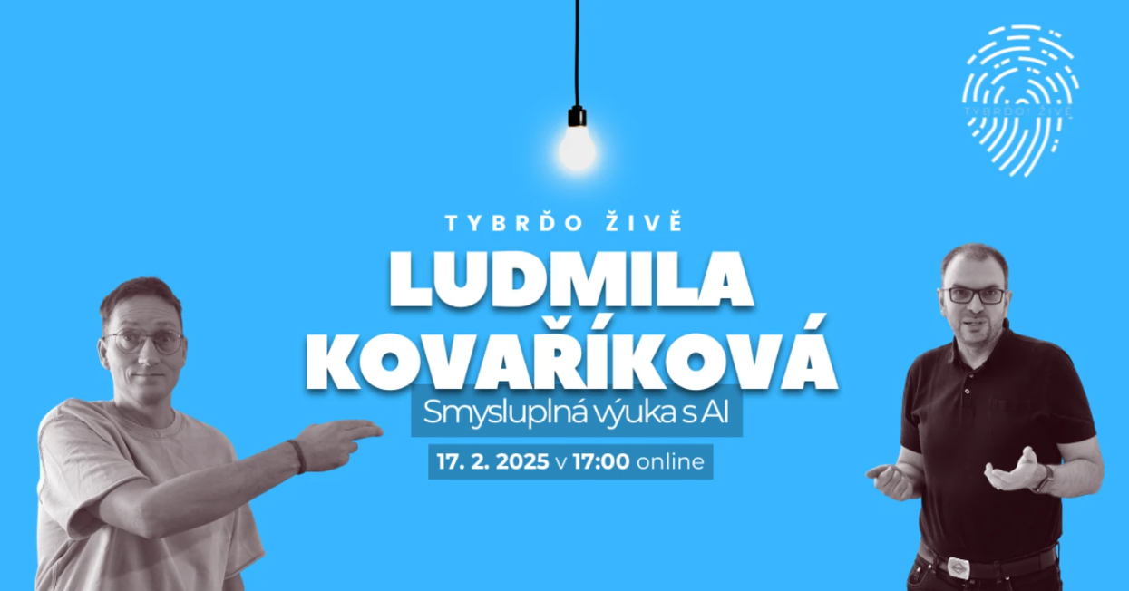
https://talkbase.io/event/ludmila-kovarikova-smysluplna-vyuka-s-ai-tybrdo-zive/gugcz

https://tybrdo.cz/
https://digitalizace.rvp.cz/faq-umela-inteligence
https://digitalizace.rvp.cz/napric-predmety/ai
https://chatveskole.cz/
https://kurikulum.aidetem.cz/
https://aidetem.cz/
DigiDay https://www.youtube.com/playlist?list=PLcyrRW-49oIQ41UxzAb0AiyT9rqBphlxU

https://chatgpt.com/
https://copilot.microsoft.com/
https://gemini.google.com/

https://www.youtube.com/watch?v=jAhEDEdq2ec
https://teachablemachine.withgoogle.com/
https://studio.code.org/
https://cleanup.pictures/
https://www.midjourney.com/home
https://duckduckgo.com/
https://www.codebreakeredu.com/chat/
https://www.magicschool.ai/
https://dream.ai/create
https://www.craiyon.com/

https://chatgpt.com/g/g-akgXA1HdK-didaktik-genius
https://chatgpt.com/g/g-uefFoRnpX-summarizer-pdf-book-article-web-text-code-image
https://www.tybrdo.cz/technologie-ve-vyuce/stredovek-anachronismy-a-umela-inteligence
https://www.tybrdo.cz/technologie-ve-vyuce/kdyz-se-slova-meni-v-obrazky

